**Amazon QuickSight Project**

**From College Boards to Dashboards: Providing Data Insights to a Community College**

# **Dataset Field Name**

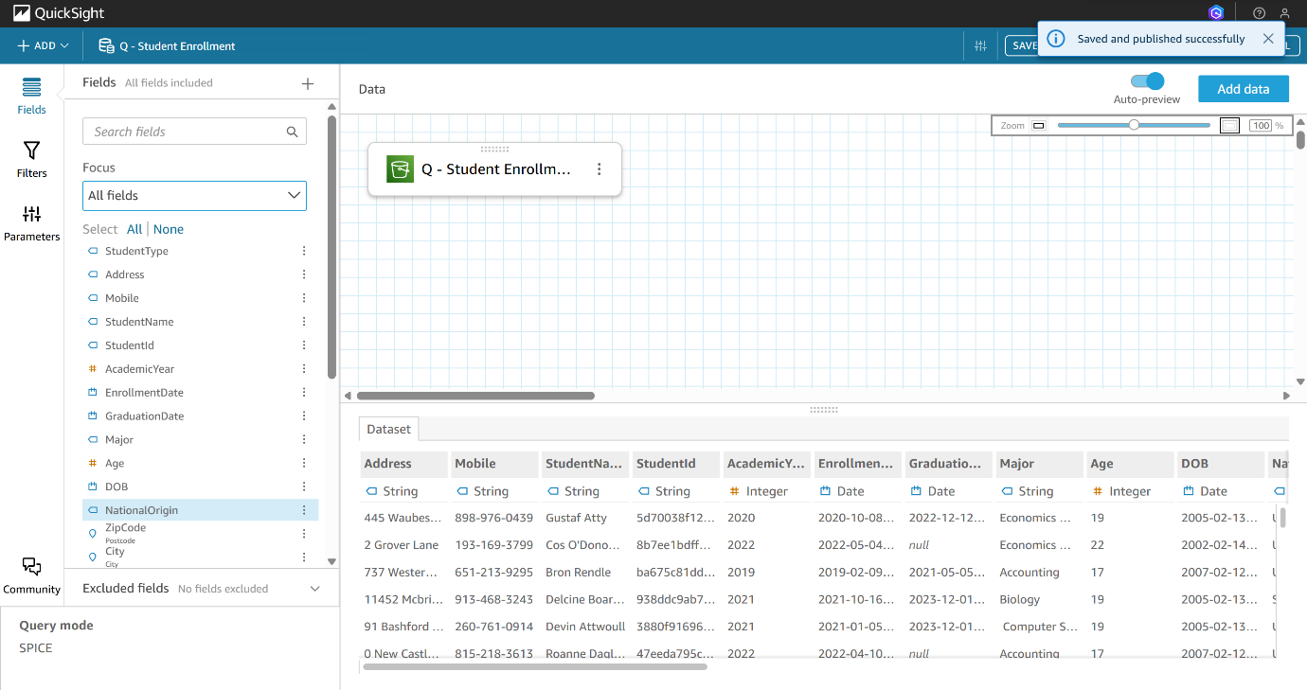

**2. Dataset Refresh Schedule**  
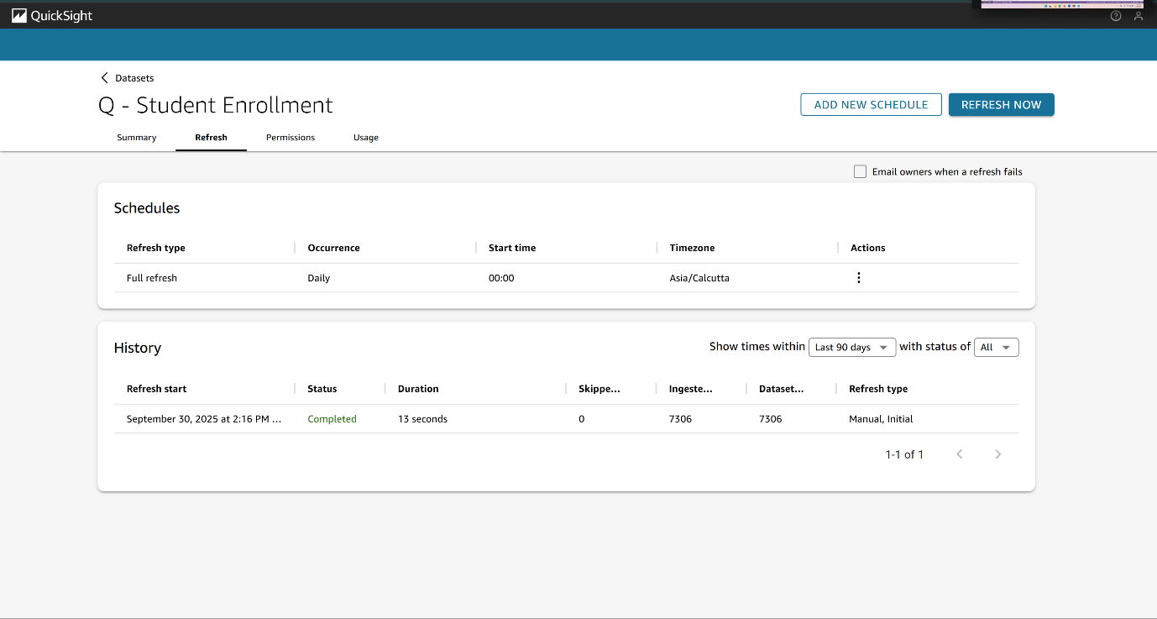

**3. Student Type Calculated Field**  
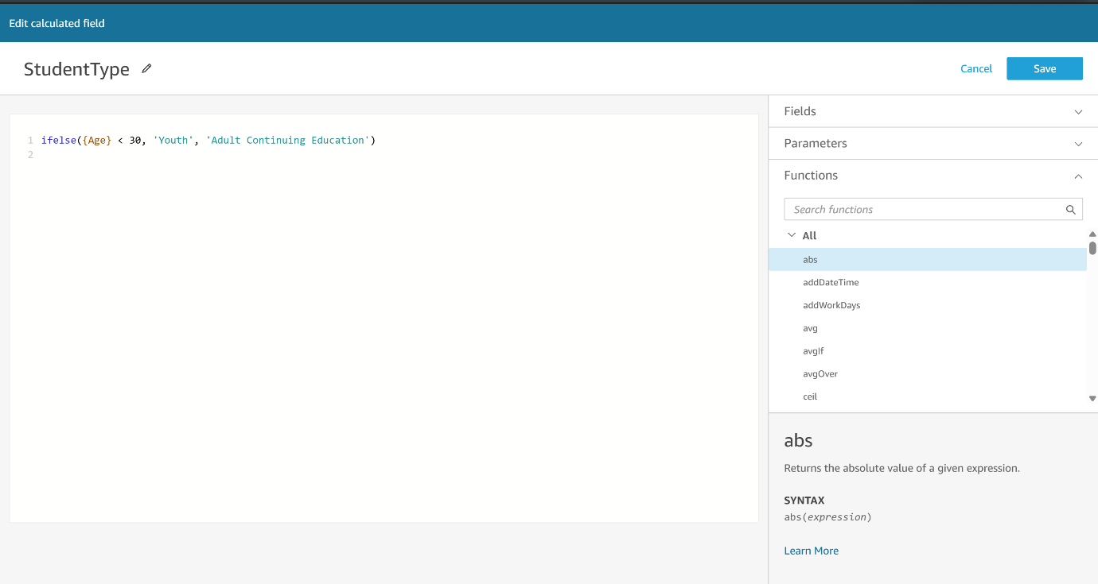

**4. Student Majors By Year**

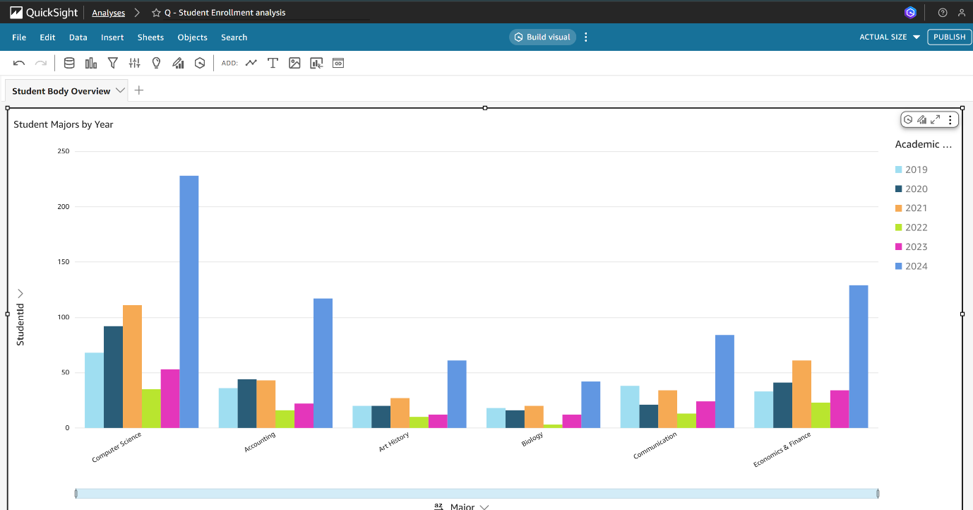

**5. Student Body Overview**  
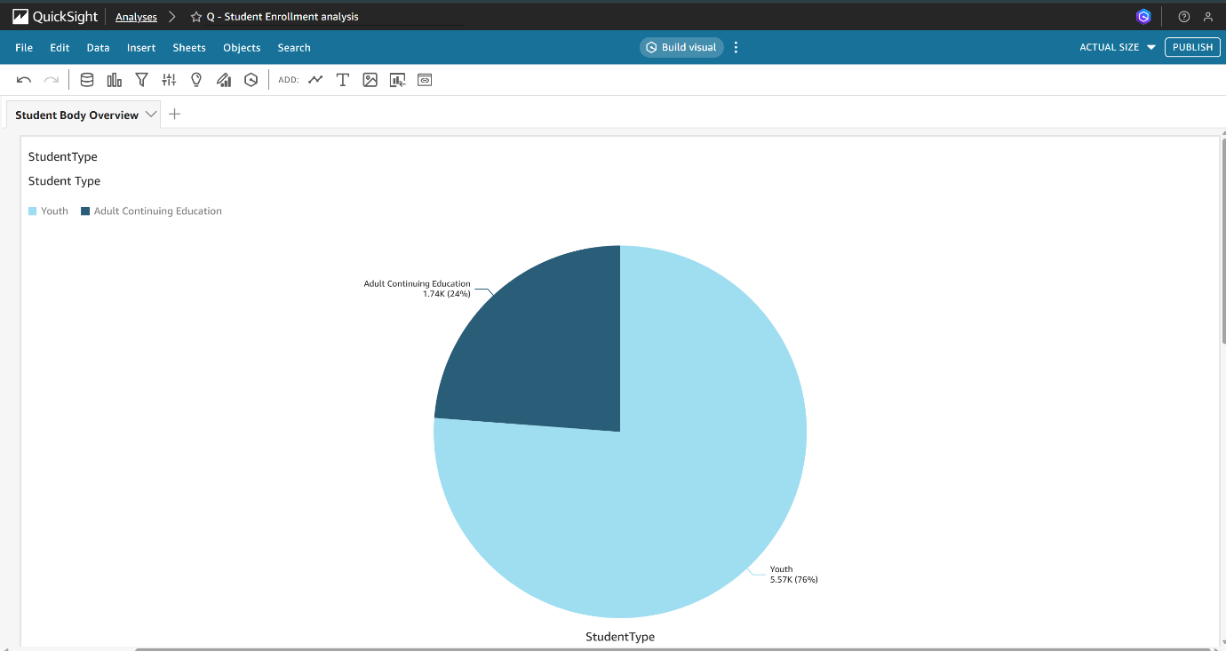

**6. Custom Topic Fields**

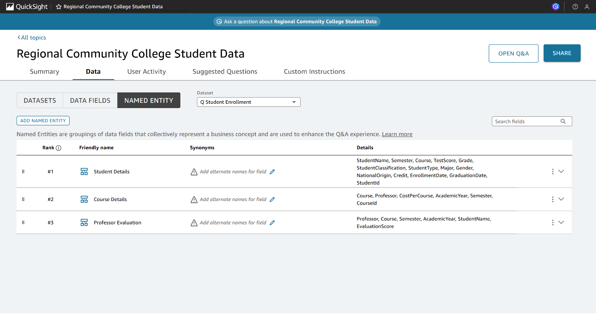

**7. Named Entity: Student Details**  
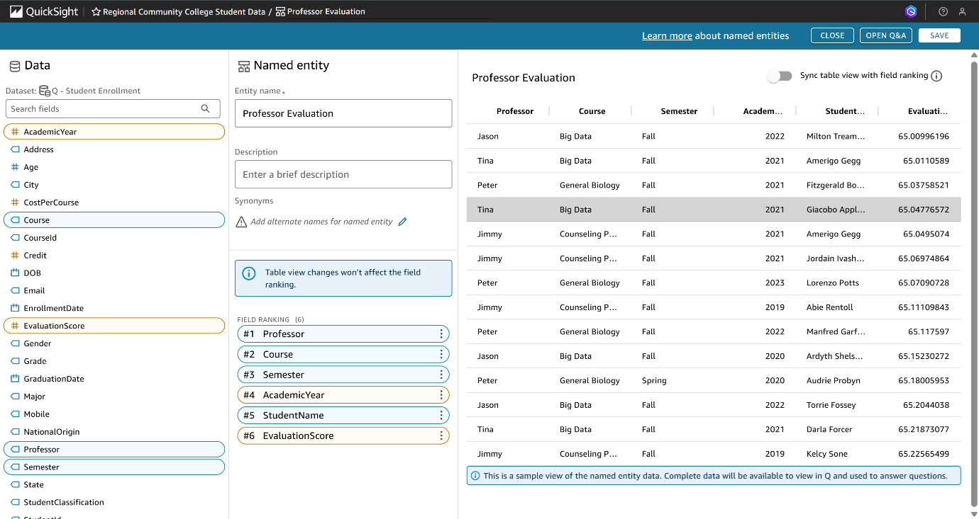

**8. Named Entity: Course Details**  
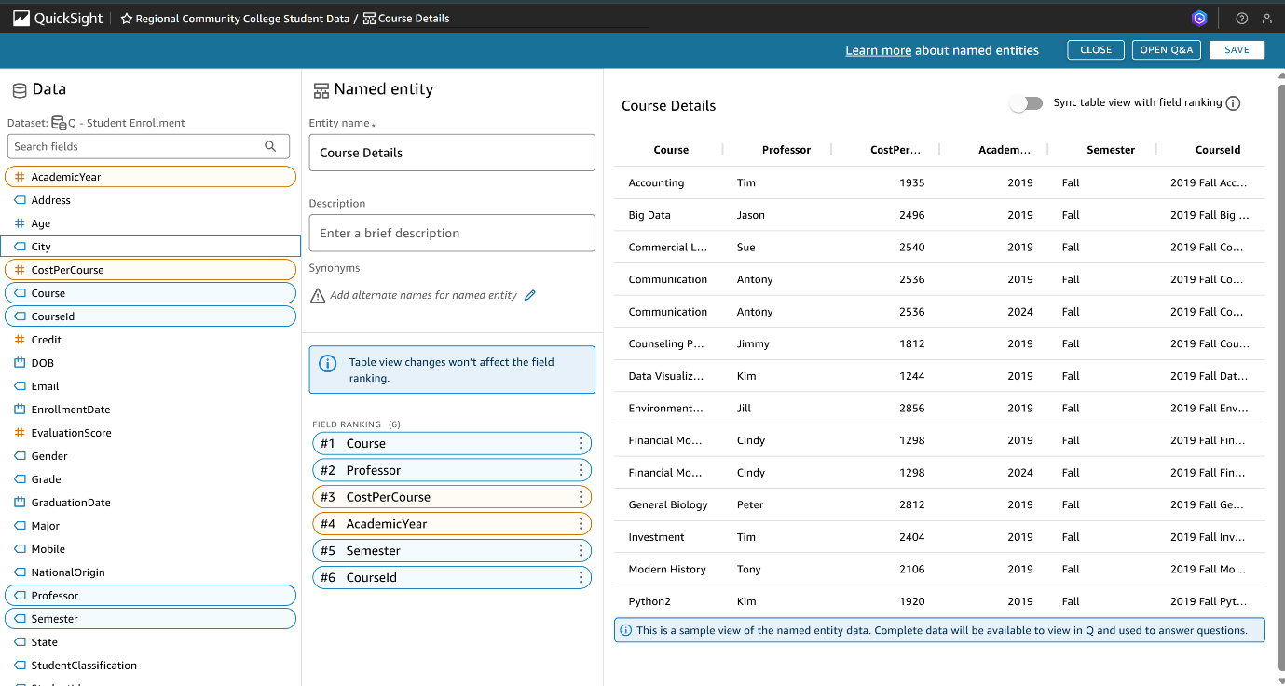

**9. Named Entity: Professor Evaluation**

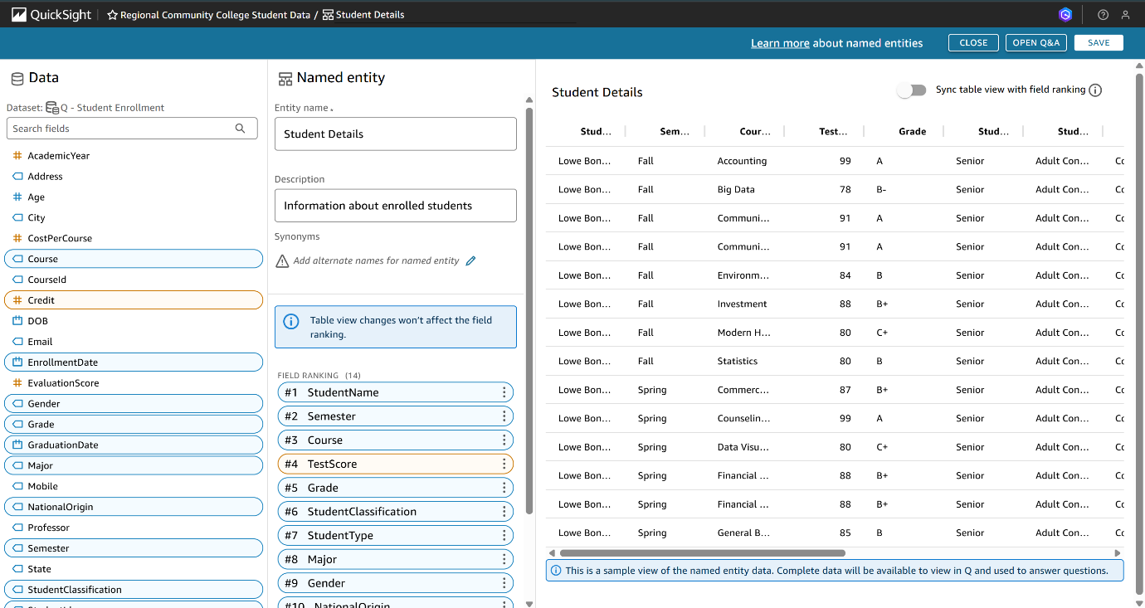

**10. Verified Answers List**  
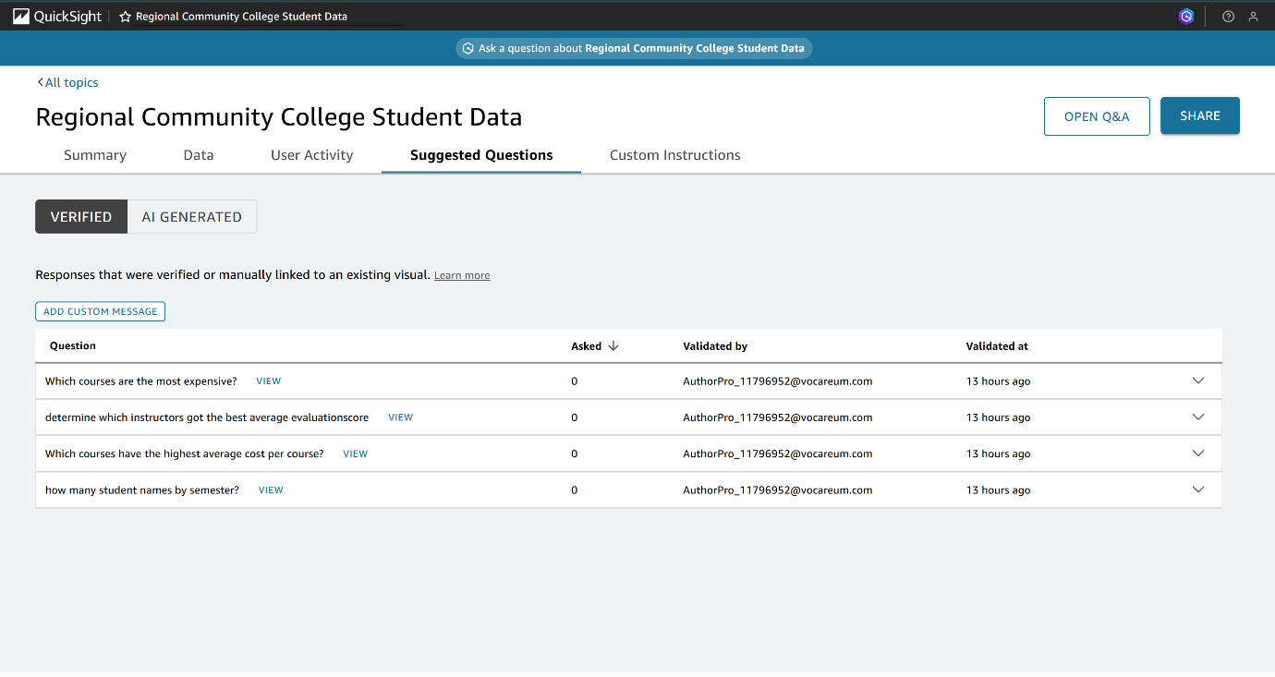

**11.Student Enrolment Dashboard**

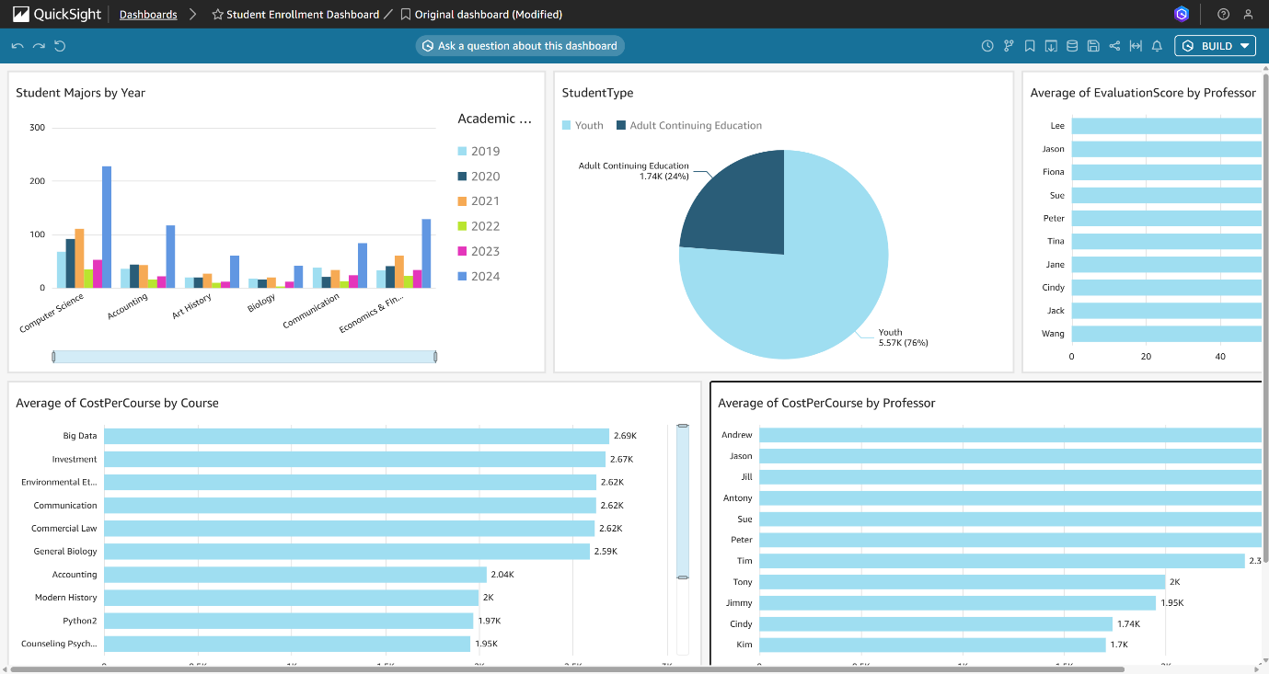

**12. Started Complex Question**

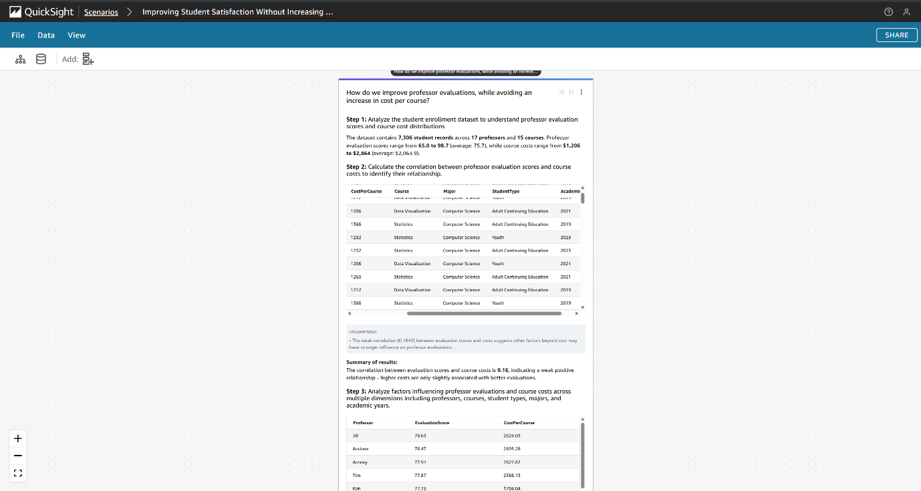

**13. Scenario Follow Up Thread**  
 13.1 Q1->Response

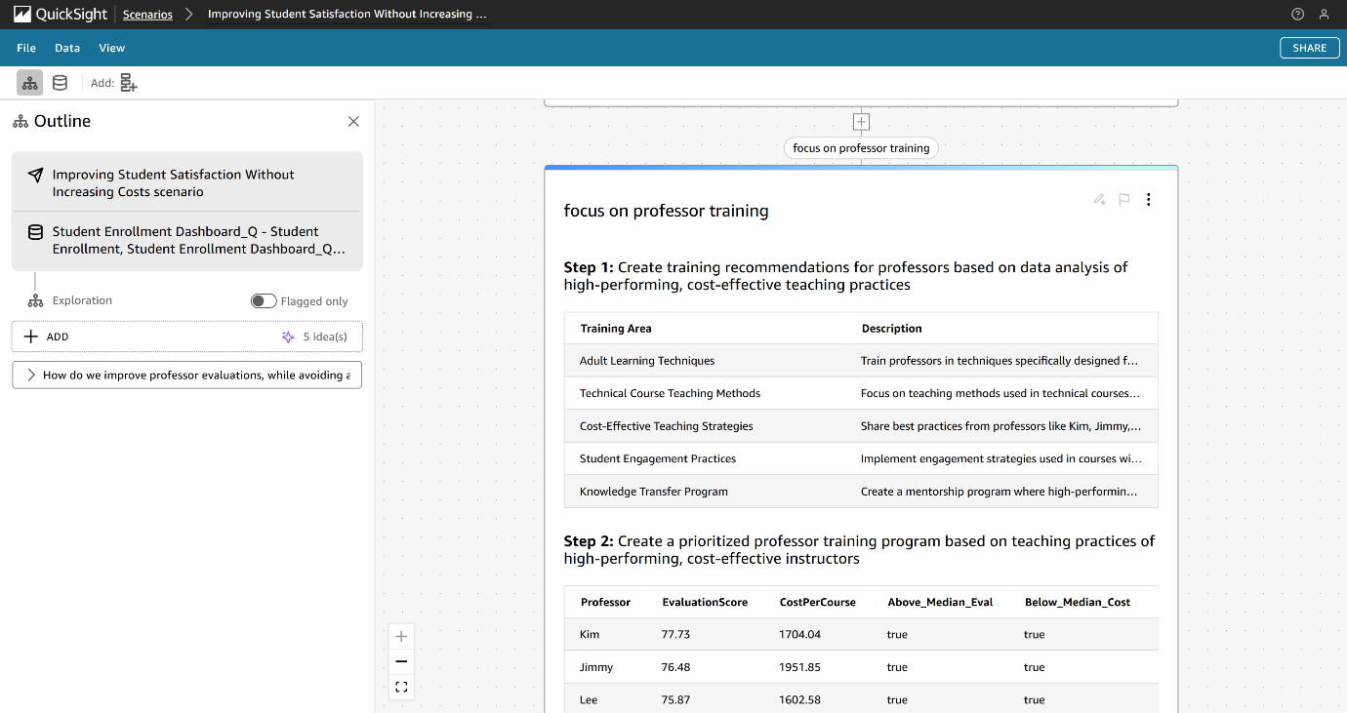

13.2 Q2->Response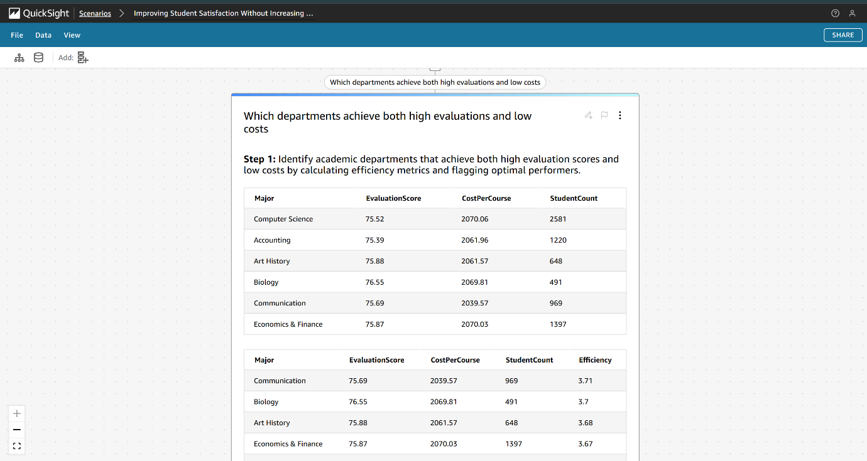

13.3 Q3->Response

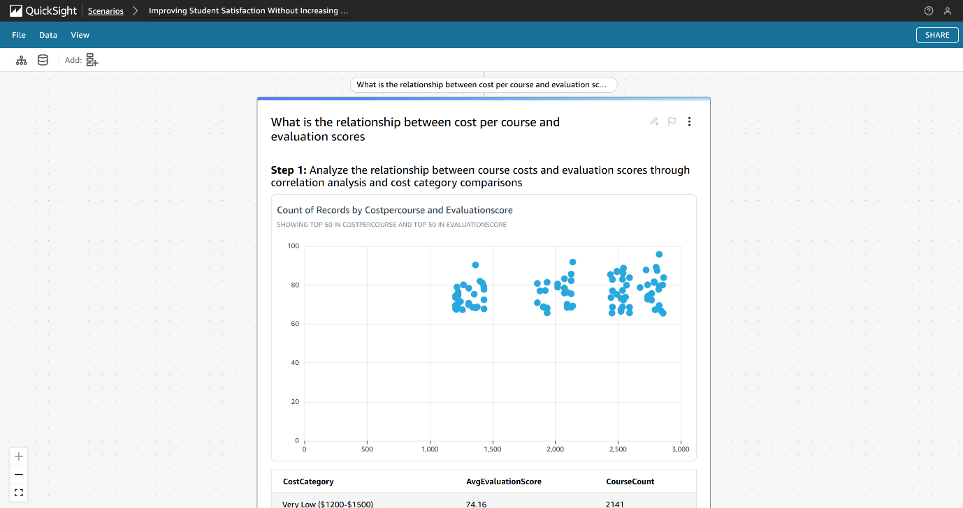

13.4 Q4->Response

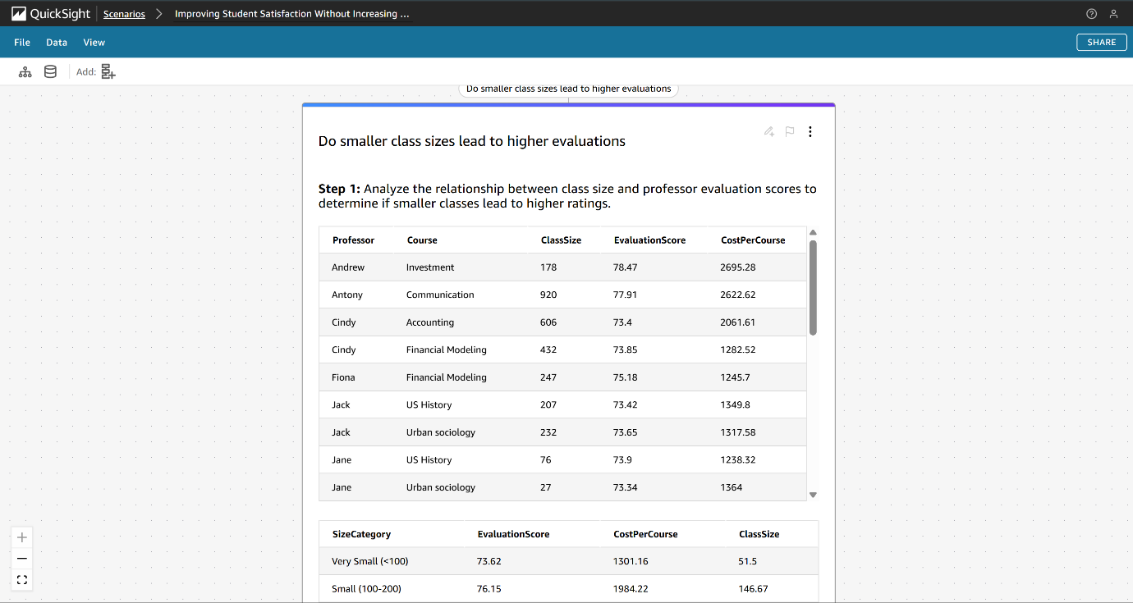

13.5 Scatter Plpt: Visualization  
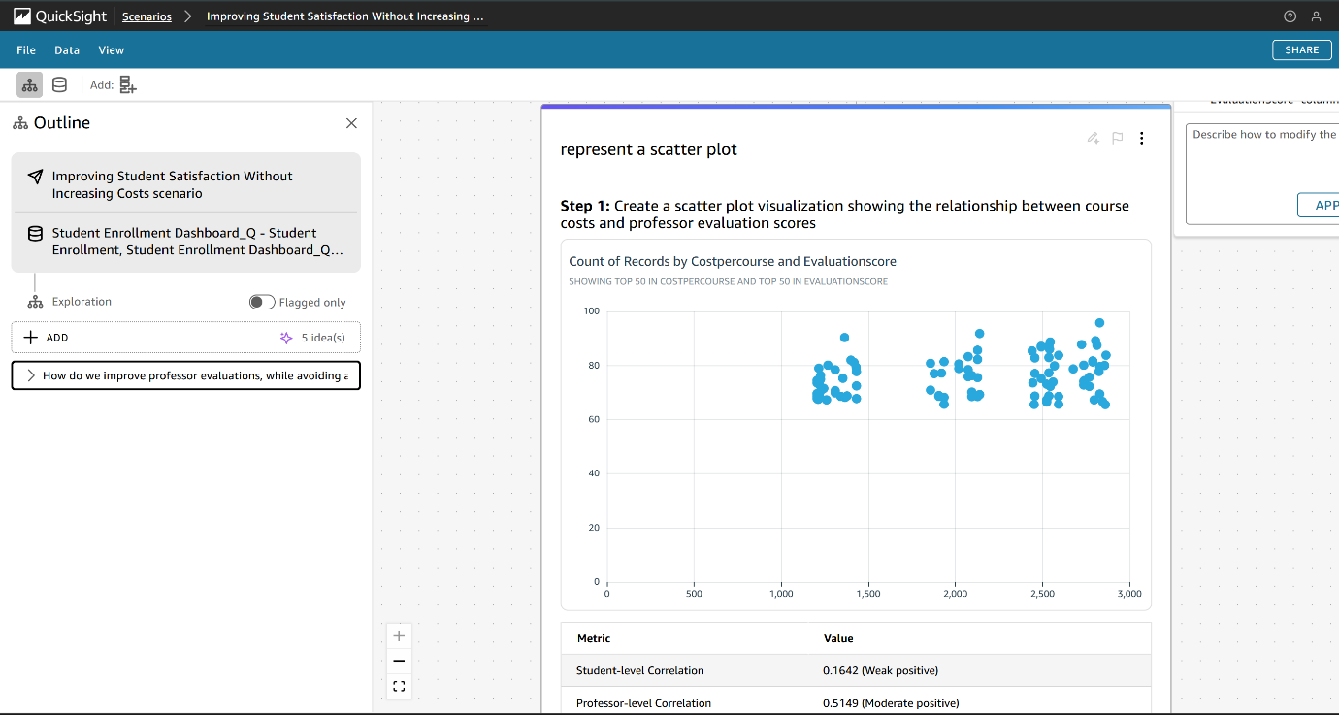

# **14. Data Story**

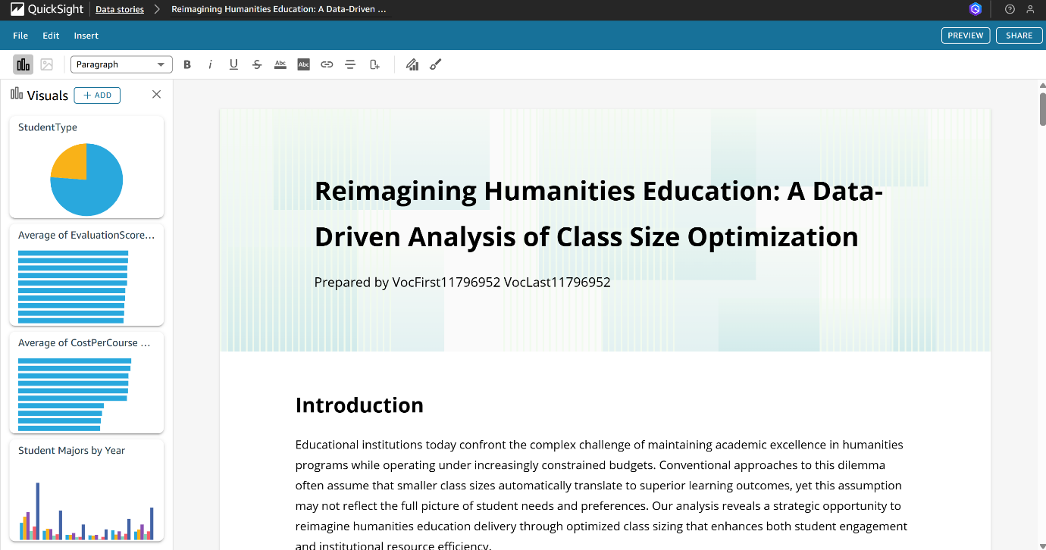

# **15. Dataset Listing**

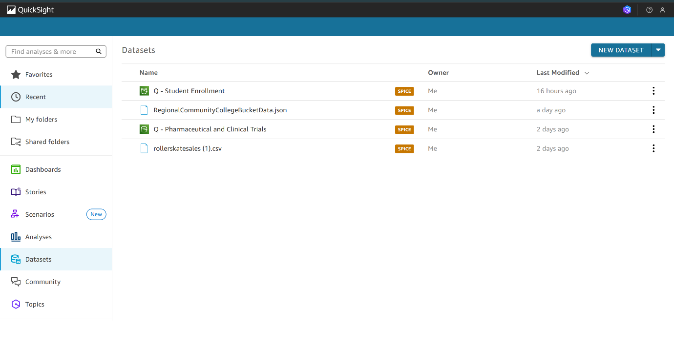

**16. Analyses Listing**  
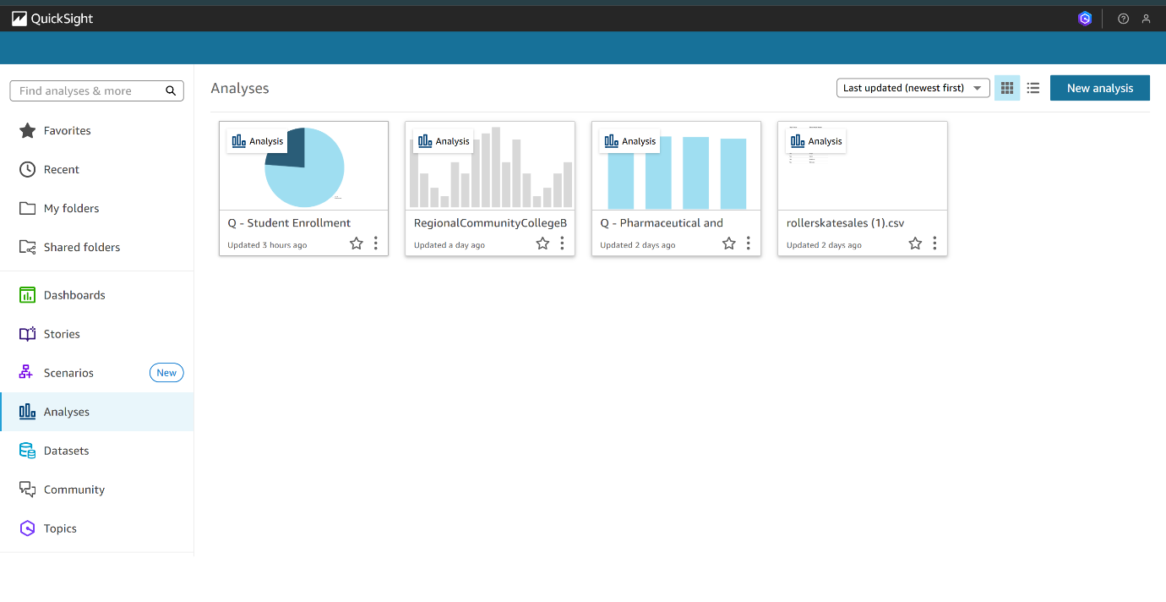

# **17. Dashboard Listing**

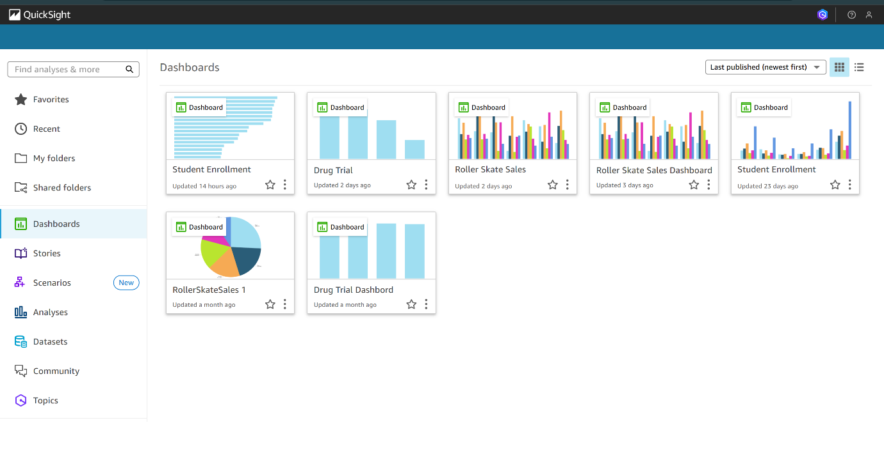

# **18. Topics Listings**

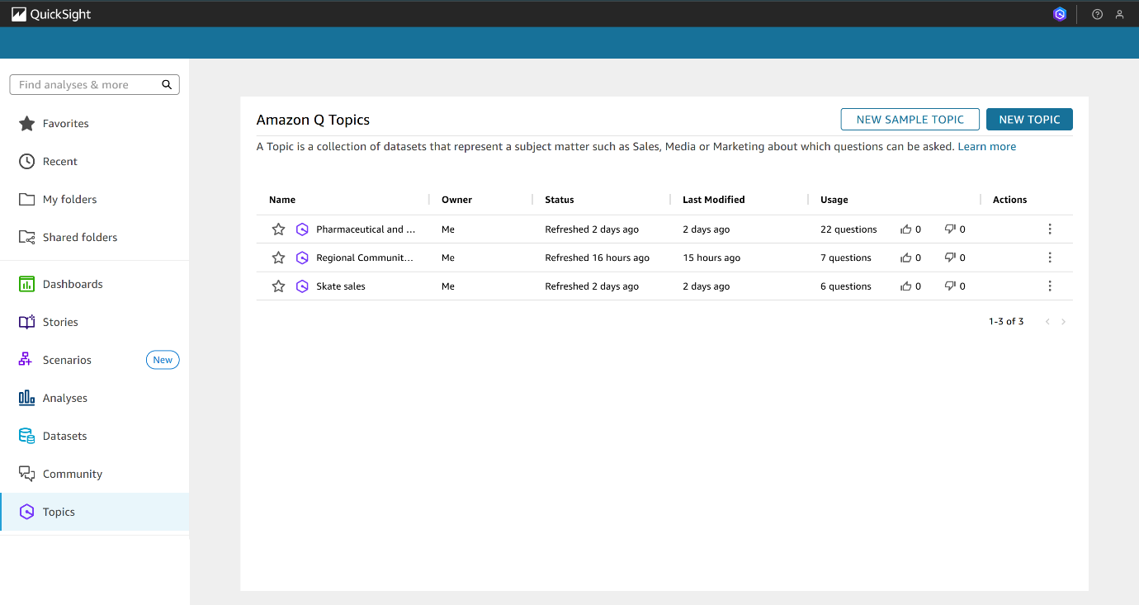

# **19. Scenario Listings**

